Leo Chai

Mrs. Goldenburg E.

Language and Literature

19 October 2019

Rationale

I chose to write a journal on Crunchyroll’s news panel to investigate how translation takes away meaning from a text. My goal is to demonstrate how language is interpreted differently in different cultural contexts, and how meaning is lost in translation.

I will be talking about a TV anime series called “Monogatari”. It is about the protagonist Araragi helping others who suffer from supernatural monsters. These series have achieved a huge financial success and massive popularity in Japan, but lacks interest in the west.

I will be analyzing how the strategic use of Japanese cultural aspects such as kanji and allusions to the religion system enhances the anime, and how a lack of cultural context takes away meanings. I will connect these points to the massive difference in the popularity of “Monogatari” in Japan and the west.

I will be creating an online article on the anime website “Crunchyroll”, which is an anime service providing a website that provides streaming service as well as articles on anime. Since my audience is anime fans looking for a new anime to watch, putting my article on this popular anime website will attract them to read my article.

Having my text on Crunchyroll also allows me to use a variety of screenshots of the anime to show examples of what I am talking about. Since anime is a graphical medium, having images will help my audience understand my analysis better.

People who go on Crunchyroll also are likely to have watched multiple anime, as Crunchyroll is a paid service, and thus would have some knowledge about the Japanese religion system and kanji. These contexts are important because they are key parts to my arguments and understanding of these contexts would make my text easier to understand.

**Truth of the Monogatari Series: Why is it so popular in Japan compared to the west**

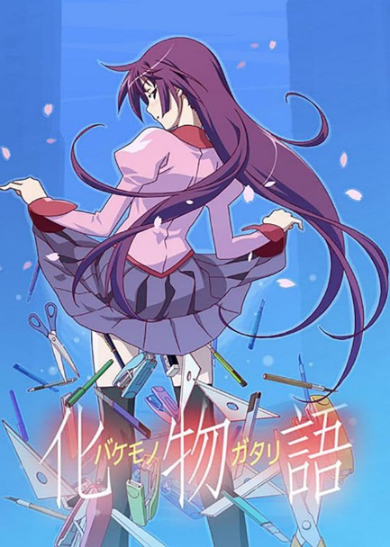 Being one of the best-selling anime TV series, many anime fans have included the "Monogatari" series in their "to-watch" list. However, this series is not very popular outside of Japan.

Figure 1: Bakemonogatari poster

Monogatari tells the story about the protagonist Araragi helping many other people who suffer from effects of kaiis. Kaiis are Japanese tradition mythical creatures including traditional monsters and gods. The story focuses on how Araragi grows and develops as he goes through different challenges. The main cause of the difference in popularity is the large amount of Japanese cultural aspects included in the series: the unique "kanji" - adopted Chinese characters in the Japanese writing system - and various aspects of the traditional Japanese religious system.

The original Monogatari light novel uses long dialogues and lengthy descriptions of Araragi's thoughts frequently. If these were to be read in the anime, it would make the anime boring, as vocalizing the dialogues and thoughts would lengthen the reading time. The director uses a trick to solve this problem: he often flashes empty shots with only kanjis to grab the reader's focus.

Figure 2 is an instance when kanji is flashed in a long conversation. The shot is not only stationary but also black and white. Therefore, it contrasts with the dynamic and colorful scenes throughout the rest of the episode.

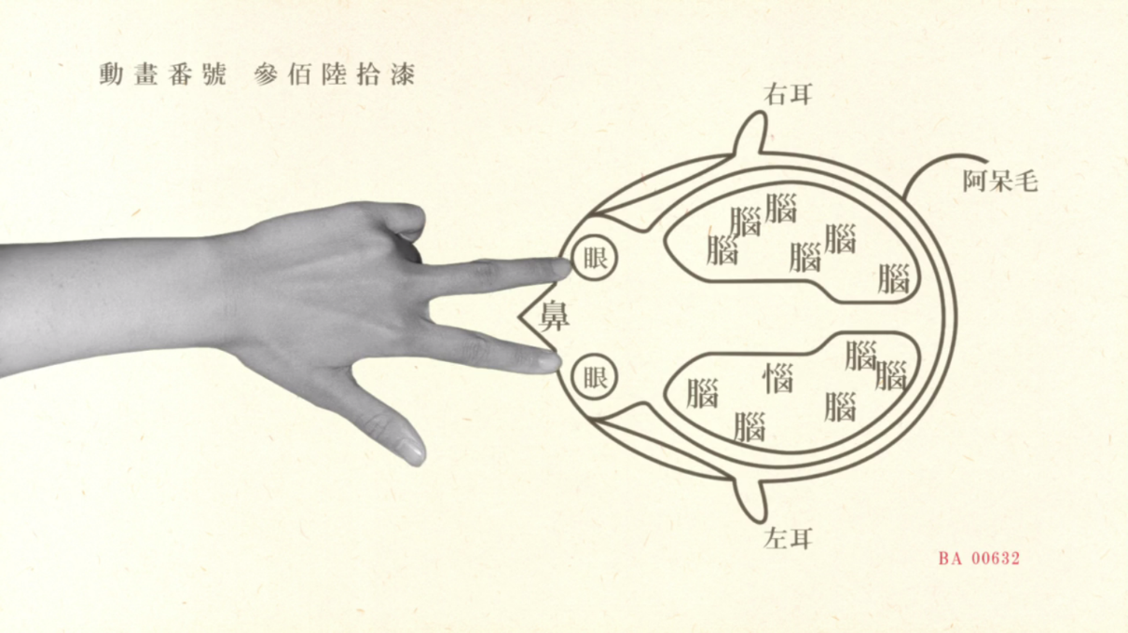

Figure 2: real life pictures and kanji are often flashed to catch the audience’s attention.

While the flashing kanjis draw the audience's attention, it also easily distracts them from the conversation they already do not want to pay attention to. To avoid this, the kanji flashed on the screen is connected with the specific scene which it interrupts, ensuring the reader stays on track. Since kanji is ideographic, with each character representing a different concept or idea, it allows the script to be read quickly.

This characteristic is explored in the anime by only showing the kanji in a short amount of time, leaving only enough time for the audience to roughly recognize the text and its meaning, and switches back to the original scene before the reader can recognize the pronunciation of the word, creating a subtle reminder of the background without distracting the audience too much from the original context.

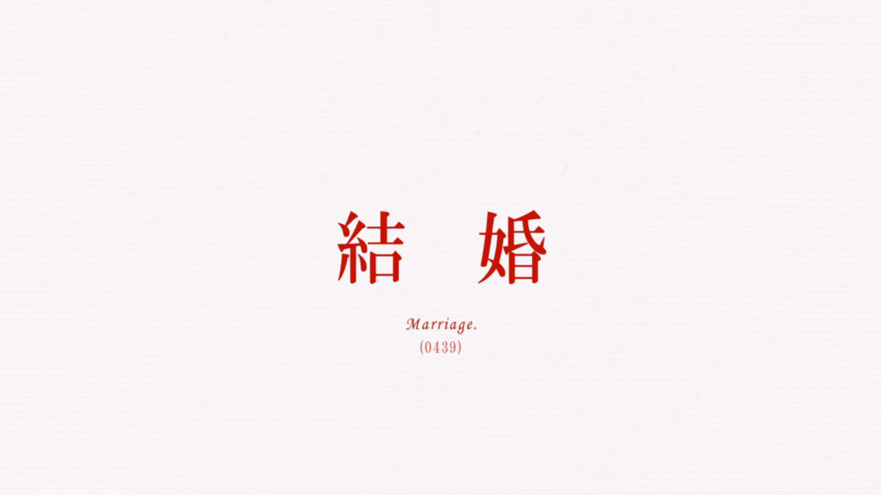

Figure 3: An example of when monogatari flashes kanji on the screen for a short amount of time

The kanji on figure 3 means "marriage", which can also be seen from the subtitles, and it is inserted within a conversation between Araragi and his girlfriend about his intentions for marriage. The strong contrast between the red-colored text and the white background pulls the audience's attention to the text.

However, this trick does not work in English. English characters are phonetic with each character representing a different sound. Thus, English text will need to be translated into sound before an interpretation. This not only breaks the subtleness but also takes longer to read, making this trick infeasible in an English text.

Similar to the cut scenes that catch the attention of the audience, translation also destroys the homonyms created by the author. Homonyms are words that have multiple meanings, and since many kanjis have similar pronunciation, Monogatari creates a wide range of homonyms, each serving a different purpose.

Many of the kaiis’ names are homonyms. For example, the "heavy stone crab" (Omoshi Kani) appears in the first episode and took away the weight of a girl, Senjougahara. The name of this kaii is a play on words. Kani, which means crab in Japanese, sounds similar to kami, which means god. So, the anime set the crab as a mythological god in the mountains of Kyushu.

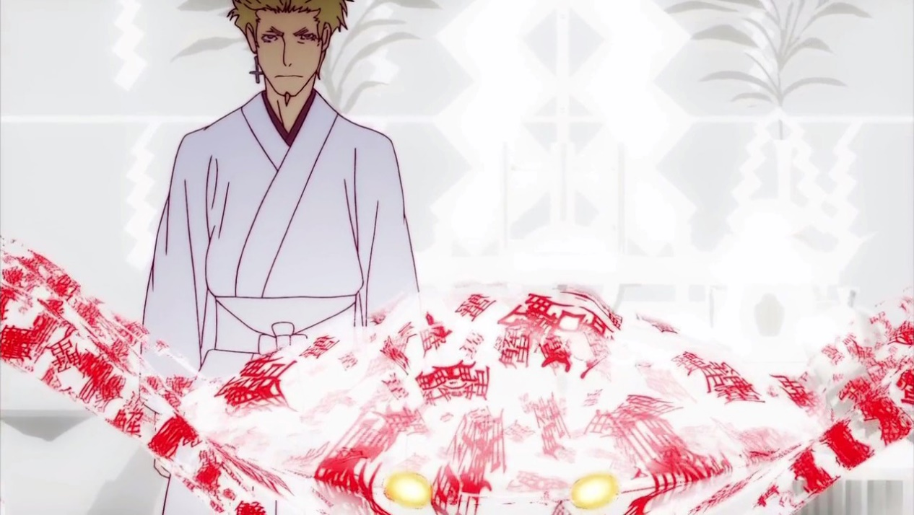

Figure 4: Heavy Stone Crab (Omoshi Kani)

The crab took away the girl's weight, because it has the word "omo" in its name, which not only stands for heavy, but also weight. The word "omo" has another meaning, similar to sentiment when used as an adjective. This is significant because this is alluding to Senjougahara's past; the reason why she is affected by the crab is because of her past experiences. Her mother joined a cult, which ruined her family when she was young. She wanted to forget her mother, so she made a deal with the heavy stone crab to take away her weight and her "omo".

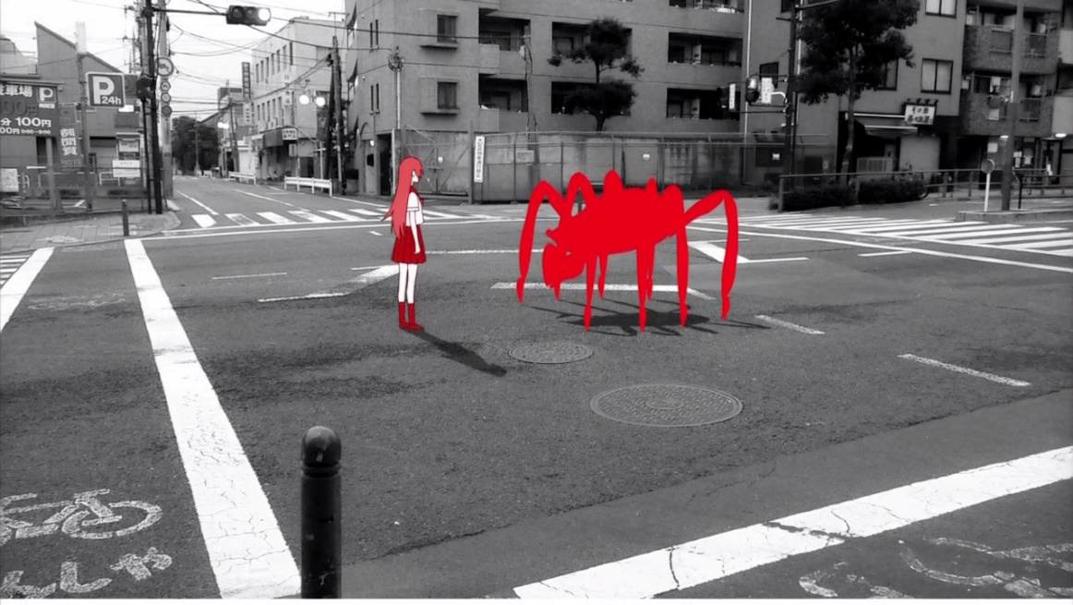

Figure 5: Senjougahara’s childhood encounter with the Heavy Stone Crab

This makes the crab a symbol for her actions of trying to escape from the emotions of her memories instead of facing them. This makes her act of defeating the crab symbolic since it represents her growth. as she started to face the emotion in her memory instead of running away from the negativity.

This symbol is weakened in the English translation as there is no longer a direct connection between the heavy stone crab and what it represents. The lack of such a critical symbol weakens the theme which is the message of the series, making the entire anime less powerful.

The idea of kaiis itself is a mind twister for many people who do not understand the Japanese culture. Unlike gods in western culture, gods in Japan are often used to refer to the natural spirits, which often do not even have a set appearance. They do not ask for worship, and a wish is enough for a response. Without an understanding of this part of Japanese culture, Senjougahara's casual interaction with a god may be confusing to the audience, distracting them from the theme of the series.

The translation process takes away many unique aspects of the series, such as techniques used to catch the attention of the audience, and the many homonyms present throughout. This causes the series to lose many of its unique selling points, which explains its low popularity overseas. However, with various aspects of Japanese culture such as kanji and the religion system mentioned throughout, it serves as a great attraction for other people to learn more about Japanese culture.